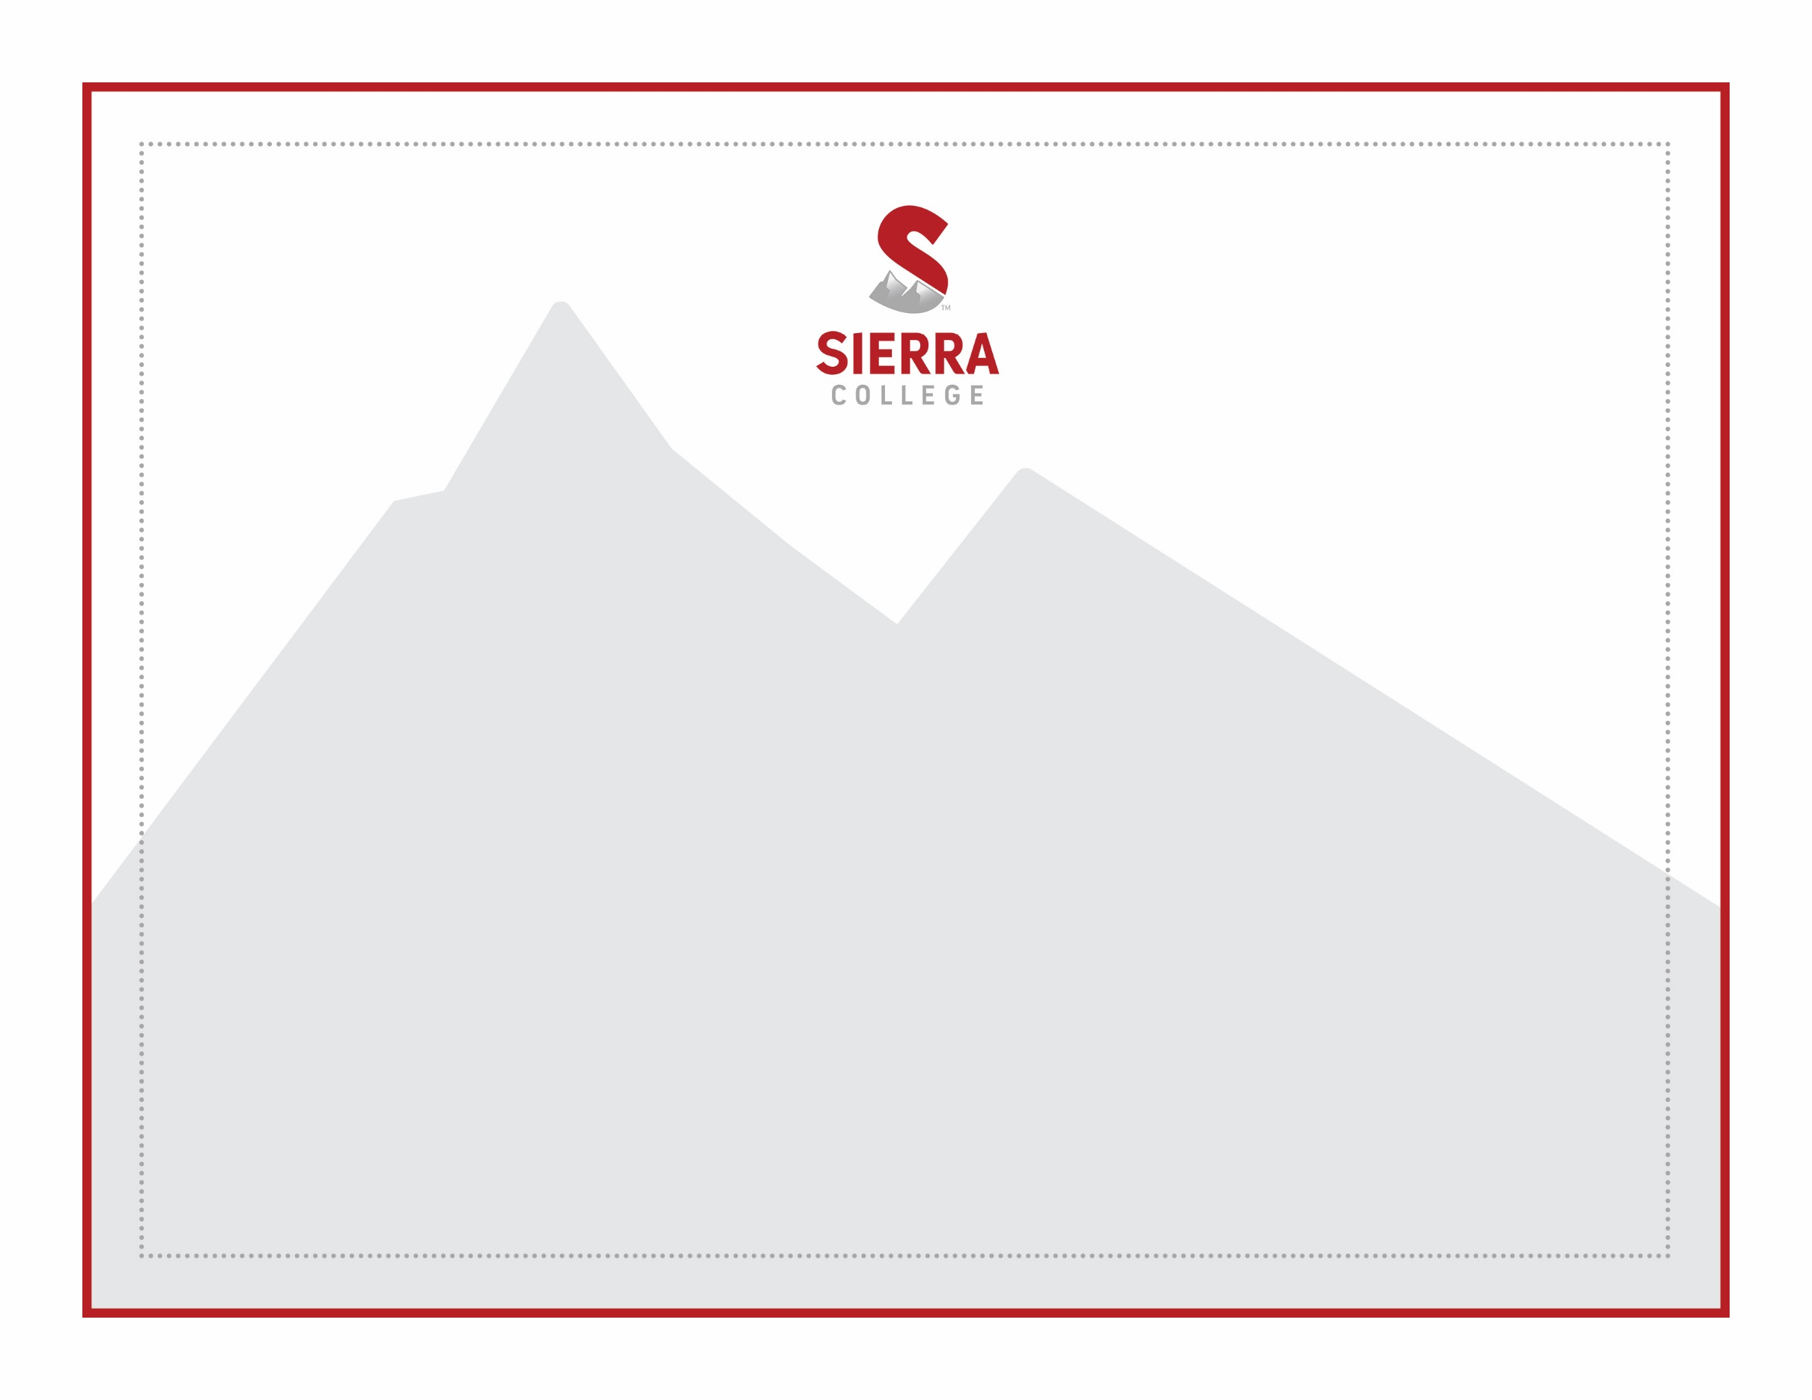

presented to

**Person Name Here**

This is the certificate body text. Description of the

Certificate: Example For Outstanding Service

Month 00, 2000

Name, Title

Department Same, Sierra College

Name, Title

Department Same, Sierra College

Name of Certificate

Might be long