­­

Event

Cost, Parking details, ticket links

**XXXX Campus** 5100 Sierra College Blvd., Rocklin, CA

**location** Room number or campus location

*event details*

• this is where some details could go

• this is where some details could go

• this is where some stuff could go

• this is where some details could go

• this is where some details could go

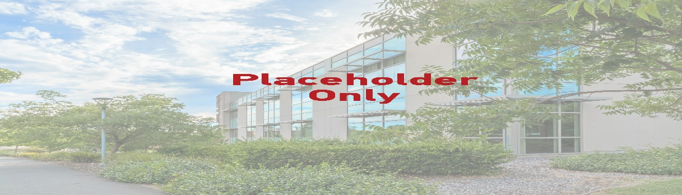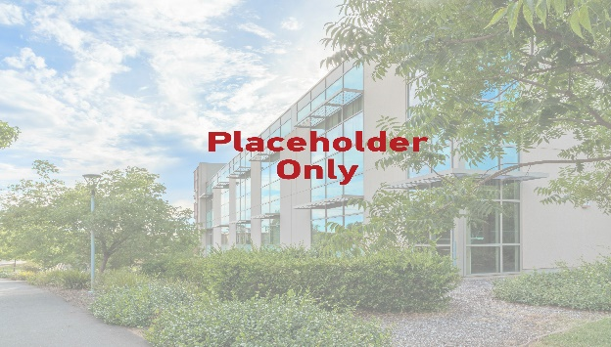

Headline

Cost, Parking details, ticket links

**XXXX Campus** 5100 Sierra College Blvd., Rocklin, CA

**location** Room number or campus location

• this is where some details could go

• this is where some details could go

• this is where some stuff could go

• this is where some details could go

• this is where some details could go

*event details*

***September 21, 2019***

***9AM–1PM***

*Free event!*

*Fun stuff!*