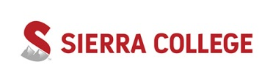

Student Learning Assessment Summary

(SLAS form)

Instructions:
- Using an assessment complete the following form for each CSLO/PSLO assessed.
- Submit all forms anonymously to your department chair before the Planning & Assessment Day.

Program/Degree/ Certificate:
Course Number and Title:
Course or Program Student Learning Outcome Assessed:
Assessment Method:  (identify and describe the assessment method) | Choose from the following:
 | - Demonstration  - Course Test/Quiz  - Standardized Exam  - Exit Interview  - Group Activity  - PreTest/PostTest  - Survey |  | - Project  - Field Placement/ Internship  - Laboratory Project  - Portfolio Review  - Presentation/ Performance  - Paper, writing assignment  - Other
 | Method Description:
Criteria for Assessment:  (institutionally shared outcome assessment criteria) | Unsatisfactory  The student displays need for improvement in knowledge, skills, and/or abilities. | Proficient  The student displays competency in knowledge, skills, and/or abilities. |  | Mastery  The student displays expertise in knowledge, skills, and/or abilities.
Results:  (record results of assessment) | _____ # of sections assessed _______ # of students assessed
Results Description (optional):

_______ Date of results
Criteria Results (# of students):
______ Unsatisfactory ______ Proficient ______ Mastery
Results Analysis:
(what did you learn?)
Actions:  (how will you improve, if needed?) | ________ Date of planned action
- YES or NO
The actions (above) correlate to a new or existing resource request? If yes, identify the request(s) below:

